Is 

June 2021
Welcome to the first issue of SPEAR News for 2021.
This newsletter provides updates on key projects and initiatives, details regarding the next User Group meeting, a summary of system enhancements in the upcoming July release and handy hints and training for users.

Key dates:
SPEAR release 5.3 is due for release July 2021
SPEAR release 5.4 is due for release October 2021

SPEAR User Group meeting
A survey was sent to all SPEAR users in April about the proposed User Group meeting in July. Thank you to all who responded, with 70% indicating their preference for an online meeting.
The SPEAR team looks forward to re-connecting with you at the first online User Group meeting on 15 July. If you wish to attend, please RSVP here by 8 July 2021.

SPEAR release 5.3
The following is a summary of the changes proposed for release in July. SPEAR Release Notes will be published on the SPEAR website shortly.
- Multi subscriber signing is being introduced to allow multiple subscribers to sign the Application Lodgement Form for a creation of easement under Section 45 of the Transfer of Land Act 1958. With this change, two different lodging parties will be able to operate in a single SPEAR application (workspace) on behalf of the receiving and relinquishing parties. The primary lodging party will be able to select their role (receiving or relinquishing party) and invite another lodging party into the application to act in the other role. The primary lodging party will be responsible for payment and lodgment of the application to Land Use Victoria.
- Several usability enhancements are being made to the lodging party functionality including:
  - allowing a lodging party to search for a SPEAR application using the lodgment number and
  - enabling a lodging party to create the application lodgment form(s) once the application is submitted to the Responsible Authority.
- The ‘Nominated Licenced Surveyor’ information will be extended to application types other than subdivisions, including boundary plans, REs, Transfer of Land Act and Local Government Act applications, and applications submitted to Surveyor-General Victoria. The Applicant Contact will be required to specify the ‘Nominated Licensed Surveyor’ when they add or modify a plan/survey document.
- The dealing type description for a 207D application will be changed in SPEAR so that it appears as ‘Section 207D - Notice'. It will no longer be referred to as a ‘Transfer of Closed Road’. In addition to this change, the residual lodgment form for 207D will now be shown as an ’Application to Request Action by the Registrar’.

ePlan update

Single CAD File Format
Land Use Victoria is pleased to see members of the surveying industry adopting the Single CAD File Format (SCFF) in their surveying and drafting workflow. The SPEAR team is supporting surveyors, ensuring all issues and enquiries are being addressed in a timely manner. Veris, as an example, have provided a SCFF compliant DXF file to the SPEAR team and recently attended a workshop to demonstrate the process of converting their SCFF to an ePlan using the ePlan Creation Service – ePlan Editor.
SCFF supporting documentation has recently been updated on the SPEAR website. Please ensure you keep up to date with the latest information.

ePlan Creation Service pilot
In May, an expression of interest was sent to identified surveying firms to participate in the ePlan Creation Service pilot. To participate in the pilot, firms needed to understand that:
- Surveyors must adopt the Single CAD Format File (SCFF) and be able to produce validated DXF files prior to the commencement of the pilot
- Only ‘Section 22 – Plan of Subdivision / Plan of Consolidation’ and ‘Section 26 – Boundary Plan’ are supported at this stage
- Surveyors are strongly encouraged to start with simple plans, i.e. no greater than 10 created lots/5 easements and simple restrictions
- Overlapping curved easements, curved building boundaries, and text-only plans are not supported at this stage.
The following firms confirmed their intention to participate in the pilot - Absolute Surveying, CAF Consulting, JH Surveying, MNG, Nobelius Land Surveyors, Paroissien Grant and Associates, Reeds Consulting, SMEC, Tomkinson Group and Veris.
This is an exciting stage for this project, with the pilot starting in July. The first activity will be a training session on 20 July.

Stakeholder engagement
The SPEAR team has been engaging with users at several events since February, with a major focus on the surveying industry rollout of the Single CAD Format File and the ePlan Creation Service pilot. Engagement activities have included presentations at seminars, meetings, and lectures:
- Single CAD Format File/ePlan webinars - 15-19 February 2021
- Landgate Western Australia meeting - 9 March 2021
- Consulting Surveyors Victoria (CSV) Seminar – 15 March 2021
- Institution of Surveyors Victoria (ISV) Regional Conference – 19 March 2021
- University of Melbourne SPEAR lecture – 29 April 2021
- University of Melbourne ePlan lecture – 20 May 2021
- CSV/ISV seminar - 21 May 2021

Geographic Names Victoria
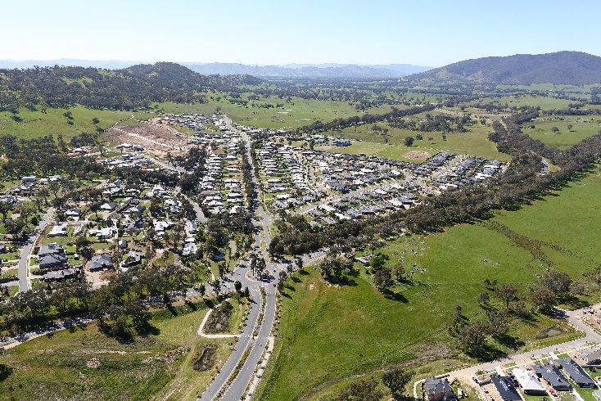
Geographic Names Victoria is progressing its review of the Naming rules for places in Victoria – 2016.
More than 6,500 visits to the Engage.vic website has generated approximately 480 submissions and over 2,200 comments.
The team is working through the comments with a Municipal Council Reference Group, Traditional Owner Reference Group and the Naming Rules Review Committee.
A draft document will be released in August and available for comments for four weeks. The final document will be released by the end of the year.
For further information, please email geo.names@delwp.vic.gov.au.

Digital Cadastre Modernisation update
Surveyor-General Victoria’s Digital Cadastre Modernisation (DCM) project has digitised 1.6 million of Victoria’s approximately 3.3 million land parcels. The team is about to complete the adjustment of the third Local Government Authority area and will soon start a pilot integration of this adjusted or upgraded parcel data to Vicmap. A more detailed update will be included in the DCM e-newsletter on the project’s website.

Handy hints
Request additional documents for endorsement
Responsible Authority users are reminded that they can use the optional action ‘Request Additional Document for Endorsement’ if they require a new version of the ‘Plan for Endorsement’ to be supplied by the Applicant Contact. This optional action is available to Responsible Authority users even if the ‘Permit Decision’ has been made and plans already endorsed.
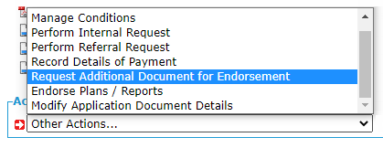
SPEAR will prompt the Responsible Authority user to select the required documents. Previously endorsed documents will be shown at the top of the list, with other documents able to be endorsed shown below.
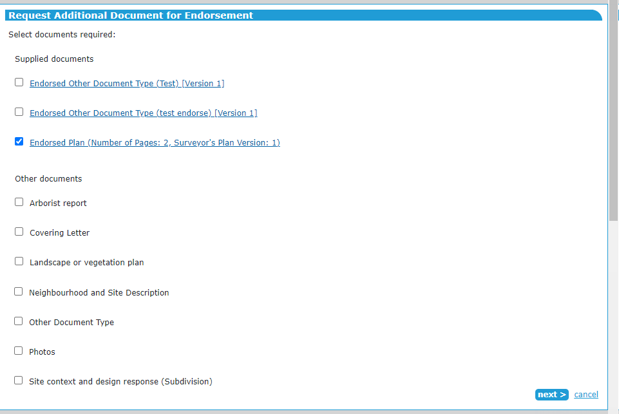
Once the user makes the required selection, and clicks ‘next’, they will be prompted to supply a reason (text or PDF) and then authenticate the action. On authentication, SPEAR will create a mandatory action for the surveyor to supply the requested document(s).

Assigning preferred contacts in an application as a lodging party
SPEAR allows a lodging party user to be nominated in an application as the preferred contact person for that application. If supplied:
- The preferred contact will be listed on the Contacts tab of the application under the Lodging Party heading, which helps other organisations involved in the application know who they need to speak to if they have questions.
- The application will automatically be set to ‘watched’ for the preferred contact if they have opted to auto-watch applications (from their user profile settings).
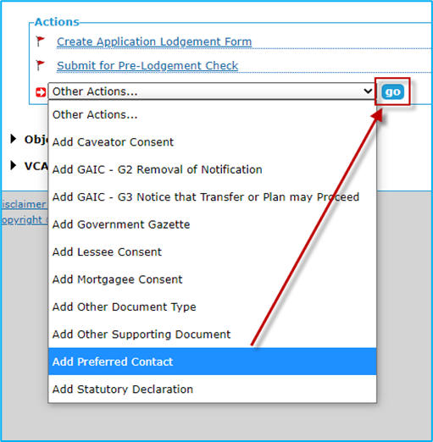
To add a preferred contact to an application, open the application in SPEAR, and go to the Details screen. From the ‘Other Actions’ drop-down list, select ‘Add Preferred Contact’ and click ‘go’. You can then choose the preferred contact from a list of SPEAR users at your organisation and notify them that they are the preferred contact (optional).
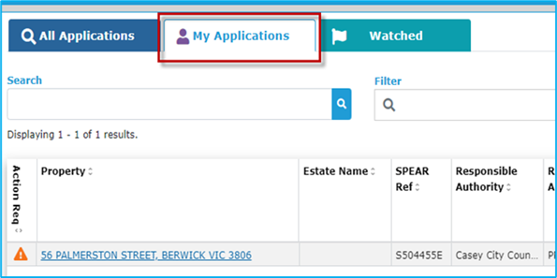
If you are assigned as the preferred contact to an application, the application will be visible to you from the My Applications list.

Supplying council consent in relation to an easement
In some cases, an Applicant Contact (surveyor) will not be involved in a Transfer of Land Act section 45 application (e.g. where the easement is over the whole of a folio and a plan is not required). To cater for this possibility, SPEAR requires the lodging party to provide the council consent letter in all cases.
As a result, the ‘Add Council Consent Letter’ action is only available to, and must be supplied by, the lodging party. If an Applicant Contact has obtained the council consent (outside of SPEAR), they should provide this to the lodging party to upload into SPEAR using the ‘Add Council Consent Letter’ action.
If the council consent letter is not supplied by the lodging party using ‘Add Council Consent Letter’, delays will be incurred at the time of lodgment.
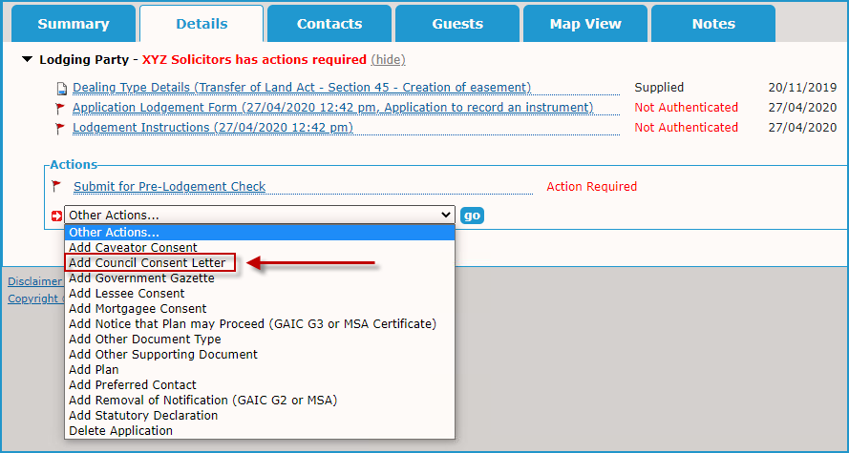
The ‘Add Council Consent Letter’ action is found in the ‘Other Actions’ drop-down list in SPEAR (refer to image below).

Current registration processing times
Once the ‘Pay & Lodge’ action in SPEAR has been completed, the application status will be updated to ‘Lodged at LUV’. This indicates the application is either in the queue to be examined OR it is being examined. SPEAR does not indicate when an application has been picked up for examination.
Land Use Victoria maintains a list of 'Current registration processing times' on the SPEAR website and displays the lodgment date of plans being examined. This helps lodging parties identify when a lodged plan is due for examination. Timeframes depend on the complexity of the plan and whether requisitions are required.
SPEAR users are reminded the SPEAR Service Desk does not provide updates on plan examination or information regarding lodged applications. If you would like to be notified when a plan is picked up for examination, you can subscribe to a Property Transaction Alert using LANDATA®. For more information, see the ‘Current registration processing times’ on the SPEAR website.

SPEAR training

Video tutorials
The SPEAR Service Desk team has completed 16 video tutorials for lodging party users. The team is now developing videos for Responsible Authority users with topics including:
- How does a Responsible Authority prepare and submit address allocations for applications in SPEAR?
- How does a Responsible Authority issue, manage and amend a planning permits in SPEAR?
- How does a Responsible Authority deal with requisitions from Land Use Victoria?
- How can a Responsible Authority use the Manage Conditions functionality in SPEAR?
Responsible Authority video tutorials will be available in coming months; users will be advised when they are on the SPEAR website.

Training dates
The following dates have been scheduled for quarterly online training sessions. If you wish to attend, please register for a session by contacting the SPEAR Service Desk on (03) 9194 0612.
Responsible Authority – council
Tuesday 3 August, Thursday 18 November
Non-statutory referral authority
Tuesday 3 August, Thursday 18 November
Lodging party
Wednesday 4 August, Thursday 4 November
Applicant Contact
Thursday 12 August, Thursday 11 November
Statutory referral authority
Thursday 12 August, Thursday 11 November

Support
The SPEAR team wants to ensure your questions and issues are resolved quickly.
Contact the SPEAR Service Desk on (03) 9194 0612:
- Press 1 for SPEAR assistance
- Press 2 for Land Use Victoria subdivision lodgment enquiries
- Press 3 for ePlan enquiries
Alternatively, you can send your enquiry by email to spear.info@delwp.vic.gov.au

Contact SPEAR
T: 03 9194 0612
E: spear.info@delwp.vic.gov.au
W: www.spear.land.vic.gov.au

© The State of Victoria Department of Environment, Land, Water and Planning 2021
This work is licensed under a Creative Commons Attribution 4.0 International licence. You are free to re-use the work under that licence, on the condition that you credit the State of Victoria as author. The licence does not apply to any images, photographs or branding, including the Victorian Coat of Arms, the Victorian Government logo and the Department of Environment, Land, Water and Planning (DELWP) logo. To view a copy of this licence, visit http://creativecommons.org/licenses/by/4.0/
Disclaimer
This publication may be of assistance to you but the State of Victoria and its employees do not guarantee that the publication is without flaw of any kind or is wholly appropriate for your particular purposes and therefore disclaims all liability for any error, loss or other consequence which may arise from you relying on any information in this publication.
Accessibility
If you would like to receive this publication in an alternative format, please telephone the DELWP Customer Service Centre on 136186, email customer.service@delwp.vic.gov.au, or via the National Relay Service on 133 677 www.relayservice.com.au. This document is also available on the internet at www.spear.land.vic.gov.au.

